MATH 213 – Homework 9
Before beginning, please (and this is Very Important!!!)
- Read the feedback I have left for you on Homework 6 in Blackboard.
- Read the solutions for Homework 6 in the Solutions section of Blackboard.
- Consult the guidance for writing about distributions of numerical variables from class
The following graph and summary statistics are calculated from the Oscars dataset we have already considered in class. Write a paragraph or two to compare the distributions of the ages of Best actor and Best actress winners. Compare the groups in terms of our usual key features of such distributions, including shape, center, spread, and outliers.
Start with a who/what/when/where sentence. There are two ways to proceed:
- Either describe both distributions the way we’ve been practicing, and then compare/contrast the two and say the main features you want to say are similar and/or different.
- Or jump straight in to the main similarity or difference between the ages of the groups you want to highlight and support it with some statistics that are shown below. Then, select the NEXT MOST IMPORTANT THING you want to highlight about the graphs, again supporting it with numbers, and so on.
Here is the graph:
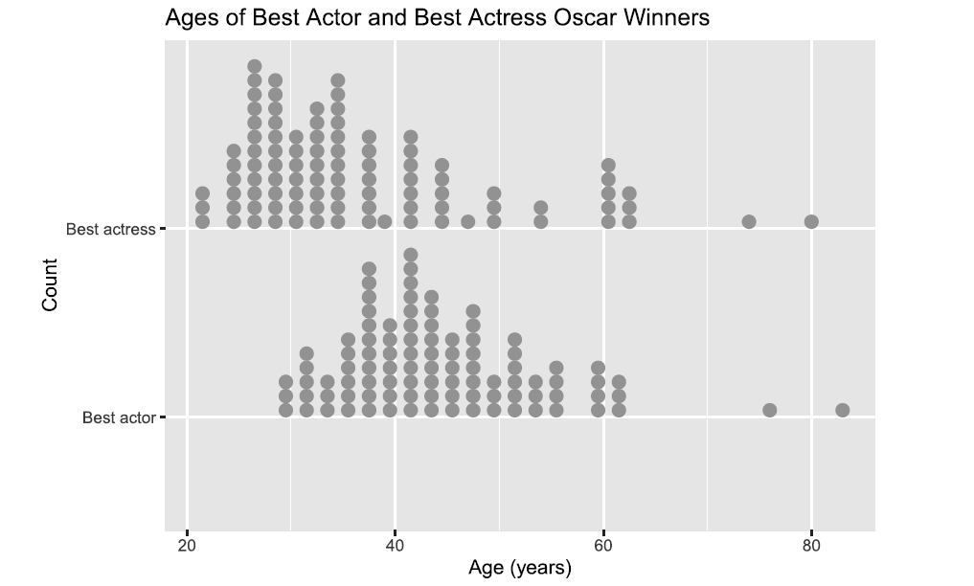
And here are the summary statistics:
